BookMyShow - Functional Test Report
Module Name: | BookMyShow - Movie Booking & Ticket Booking Functional Test Cases
Test Case ID: | BMS-TC-001
Tester Name: | Vaishnavi Thakor
Test Case Description: | To validate the functionality of city selection, movie search, movie details, showtime selection, cinema selection, seat selection, booking, offers, payment, booking confirmation, and account booking history on the BookMyShow application.
Prerequisites: | 1. Stable internet connection 2. Supported browser/app 3. Valid BookMyShow access 4. Available movie/show data 5. Test account and payment method for applicable scenarios
Environment Information: | Webpage URL: https://in.bookmyshow.com/

Scenario ID: BMS-001
Scenario: | City Selection
Test Steps: | Open BookMyShow and select the required city
Test Input: | City: Ahmedabad
Expected Results: | Selected city should be displayed and city-specific movies, cinemas and showtimes should load.
Actual Results: | Ahmedabad selected and city-specific content displayed.
Status: | Pass
Comments: | City selection works as expected.
Screenshots:
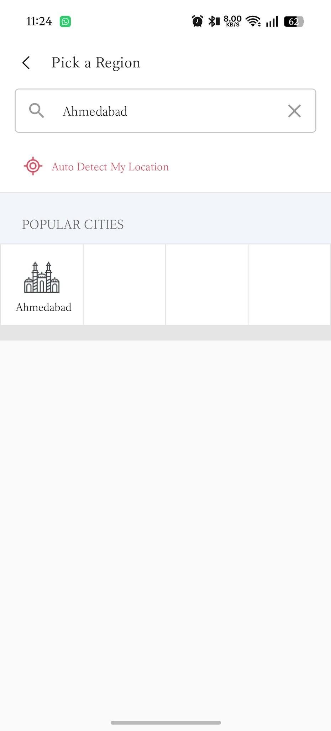
Scenario ID: BMS-002
Scenario: | Movie Search
Test Steps: | 1. Open search  2. Enter a movie name  3. Select the movie from results
Test Input: | Movie: currently listed movie
Expected Results: | Relevant movie results should be displayed for the entered search term.
Actual Results: | Relevant movie result displayed.
Status: | Pass
Comments: | Search functionality works correctly.
Screenshots:
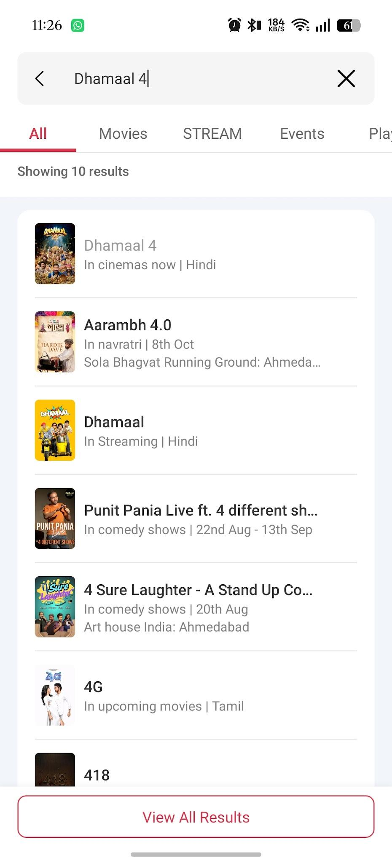
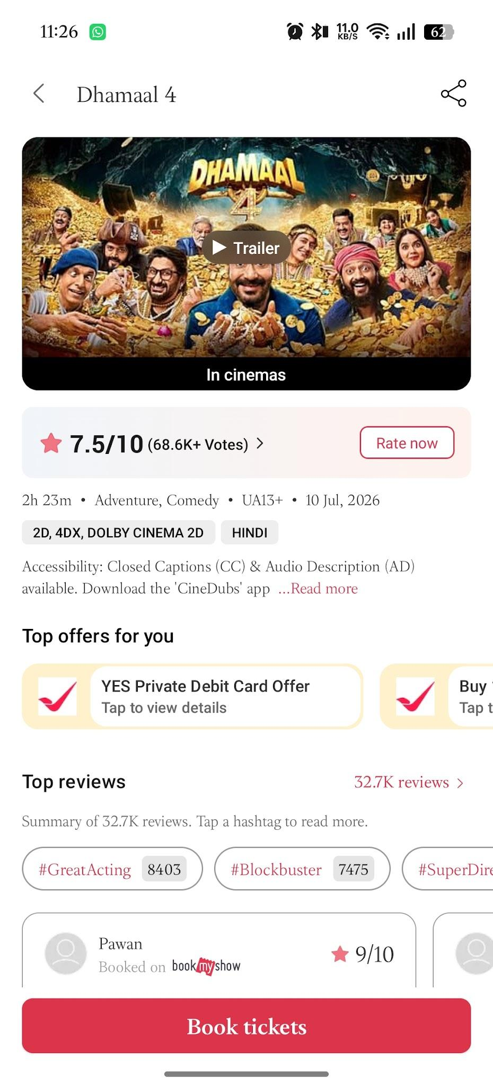
Scenario ID: BMS-003
Scenario: | Movie Details
Test Steps: | 1. Search for a movie  2. Open the movie details page
Test Input: | Available movie
Expected Results: | Movie title, language, duration, genre and other available details should be displayed.
Actual Results: | Movie details page opened with available information.
Status: | Pass
Comments: | Movie information displayed correctly.
Screenshots:
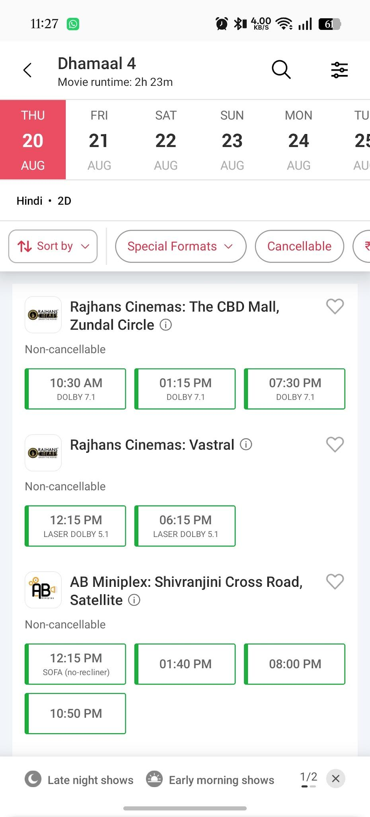
Scenario ID: BMS-004
Scenario: | Movie Language Selection
Test Steps: | 1. Open a movie listing  2. Check available language/version options
Test Input: | Available language
Expected Results: | Available language/version options should be displayed where applicable.
Actual Results: | Available language/version options displayed.
Status: | Pass
Comments: | Language information is clear.
Screenshots:
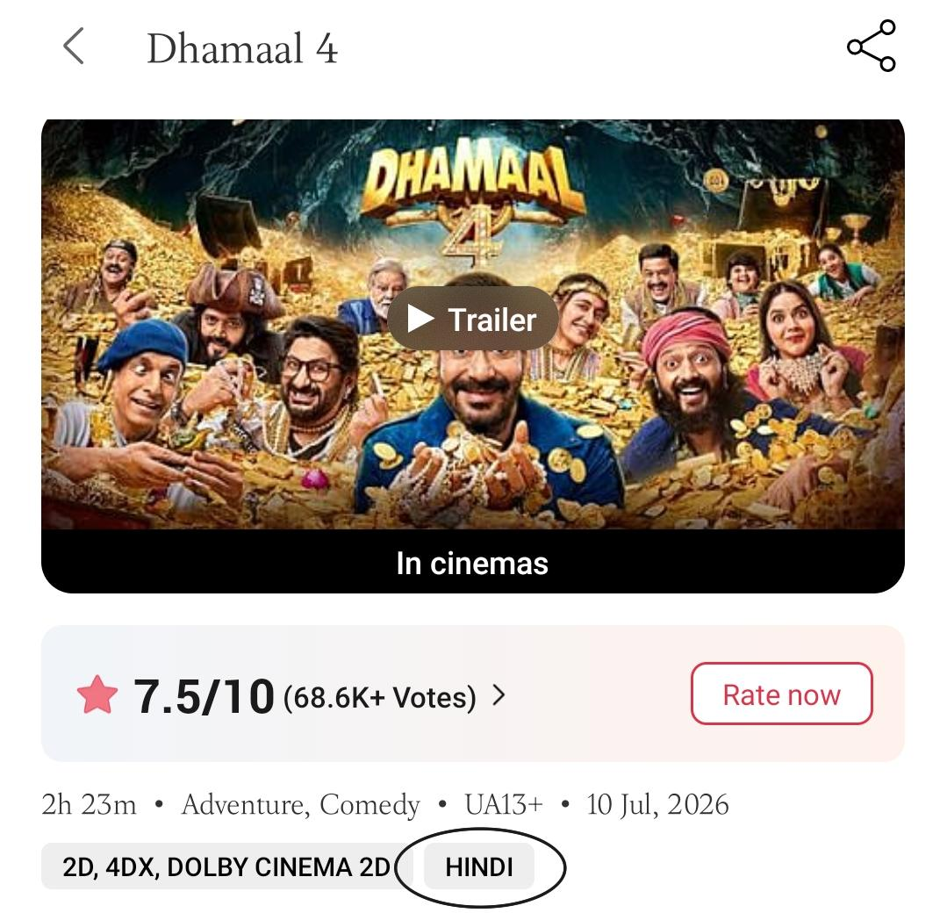
Scenario ID: BMS-005
Scenario: | Select Movie Date
Test Steps: | 1. Open booking/showtime section  2. Select an available date
Test Input: | Available date
Expected Results: | Showtimes for the selected date should be displayed.
Actual Results: | Showtimes for the selected date displayed.
Status: | Pass
Comments: | Date selection works correctly.
Screenshots:
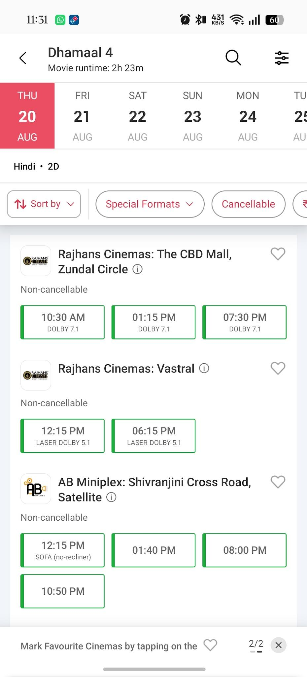
Scenario ID: BMS-006
Scenario: | Cinema Selection
Test Steps: | 1. Select movie and date  2. Choose an available cinema
Test Input: | Available cinema
Expected Results: | Selected cinema and its available shows should be displayed.
Actual Results: | Selected cinema and available shows displayed.
Status: | Pass
Comments: | Cinema selection works correctly.
Screenshots:
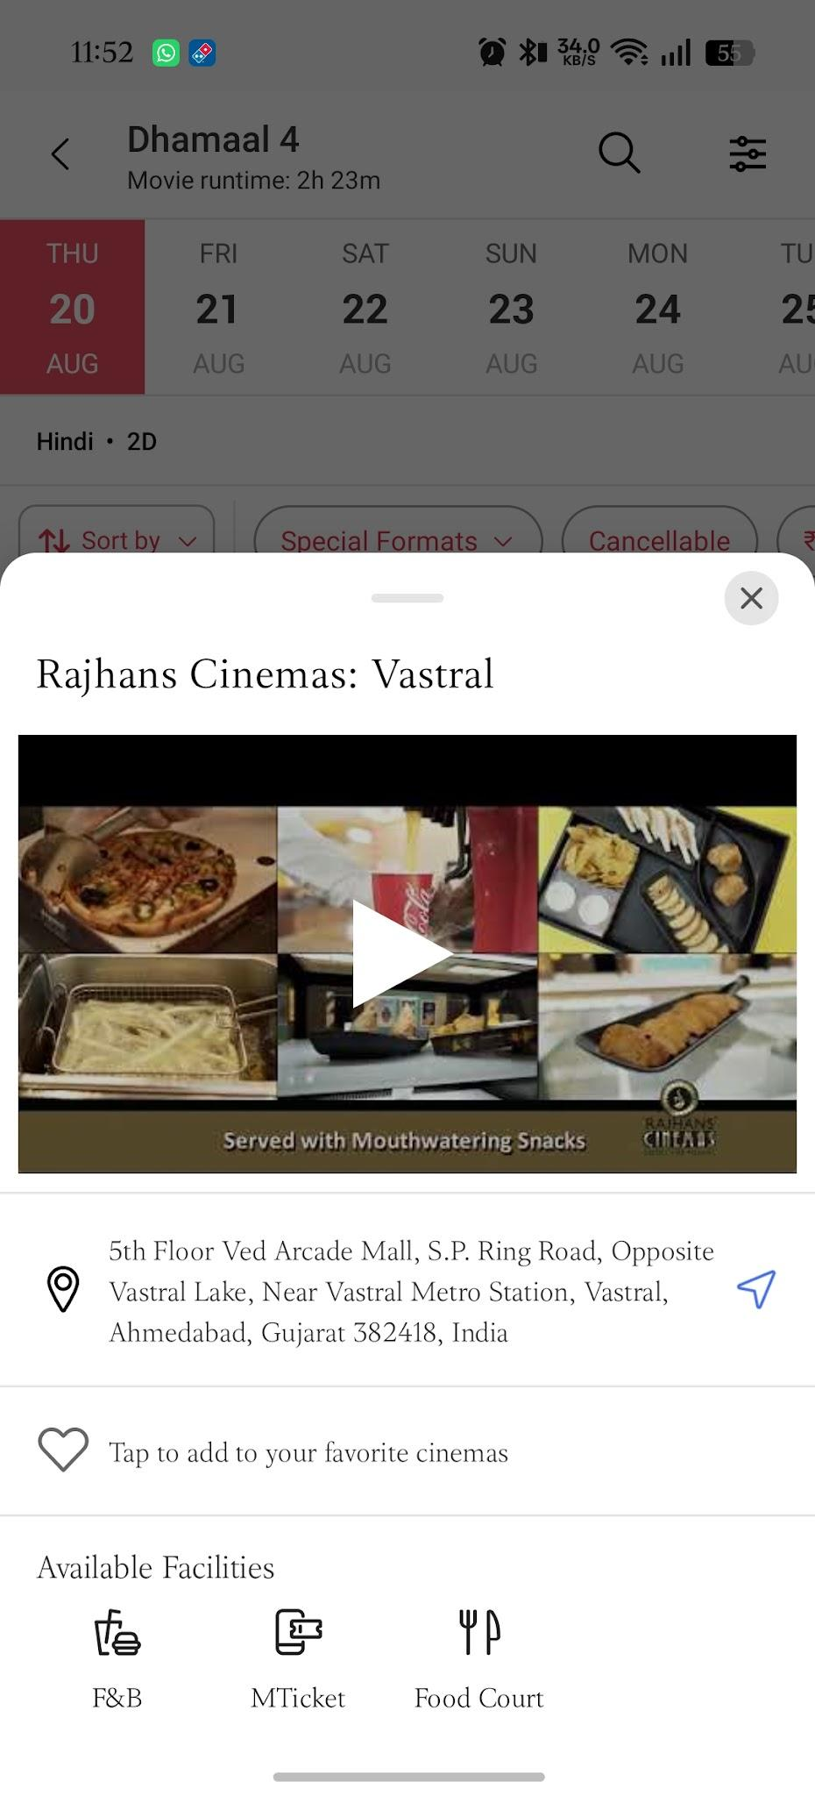

Scenario ID: BMS-007
Scenario: | Showtime Selection
Test Steps: | 1. Select cinema  2. Select an available showtime
Test Input: | Available showtime
Expected Results: | Seat selection/booking flow should open for the selected show.
Actual Results: | Seat selection flow opened for selected show.
Status: | Pass
Comments: | Showtime selection works correctly.
Screenshots:
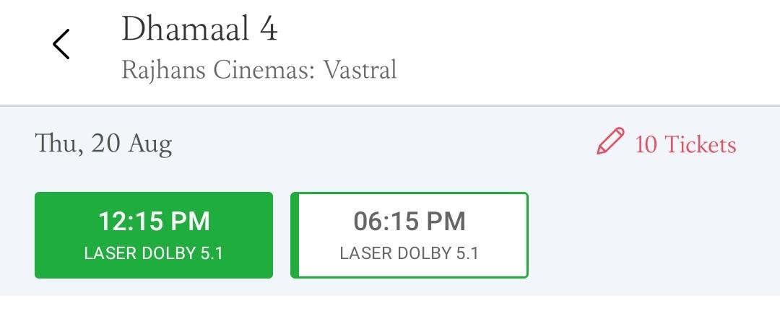
Scenario ID: BMS-008
Scenario: | Seat Selection
Test Steps: | 1. Open seat layout  2. Select available seats  3. Continue
Test Input: | Two available seats
Expected Results: | Selected seats should be highlighted and booking summary should update.
Actual Results: | Selected seats highlighted and summary updated.
Status: | Pass
Comments: | Seat selection feedback is clear.
Screenshots:
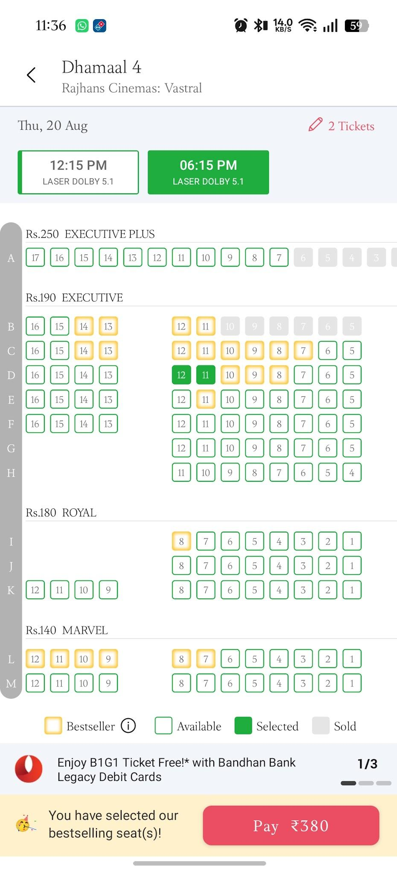
Scenario ID: BMS-009
Scenario: | Unavailable Seat Validation
Test Steps: | 1. Open seat layout  2. Try selecting an unavailable/booked seat
Test Input: | Unavailable seat
Expected Results: | Unavailable seat should not be selectable.
Actual Results: | Unavailable seat could not be selected.
Status: | Pass
Comments: | Negative seat selection handled correctly.

Scenario ID: BMS-010
Scenario: | Booking Summary
Test Steps: | 1. Select movie, cinema, showtime and seats  2. Open booking summary
Test Input: | Selected movie/show/2 seats
Expected Results: | Summary should show correct movie, cinema, showtime, seats and payable amount.
Actual Results: | Booking summary displayed selected details and amount.
Status: | Pass
Comments: | Booking summary is accurate.
Screenshots:
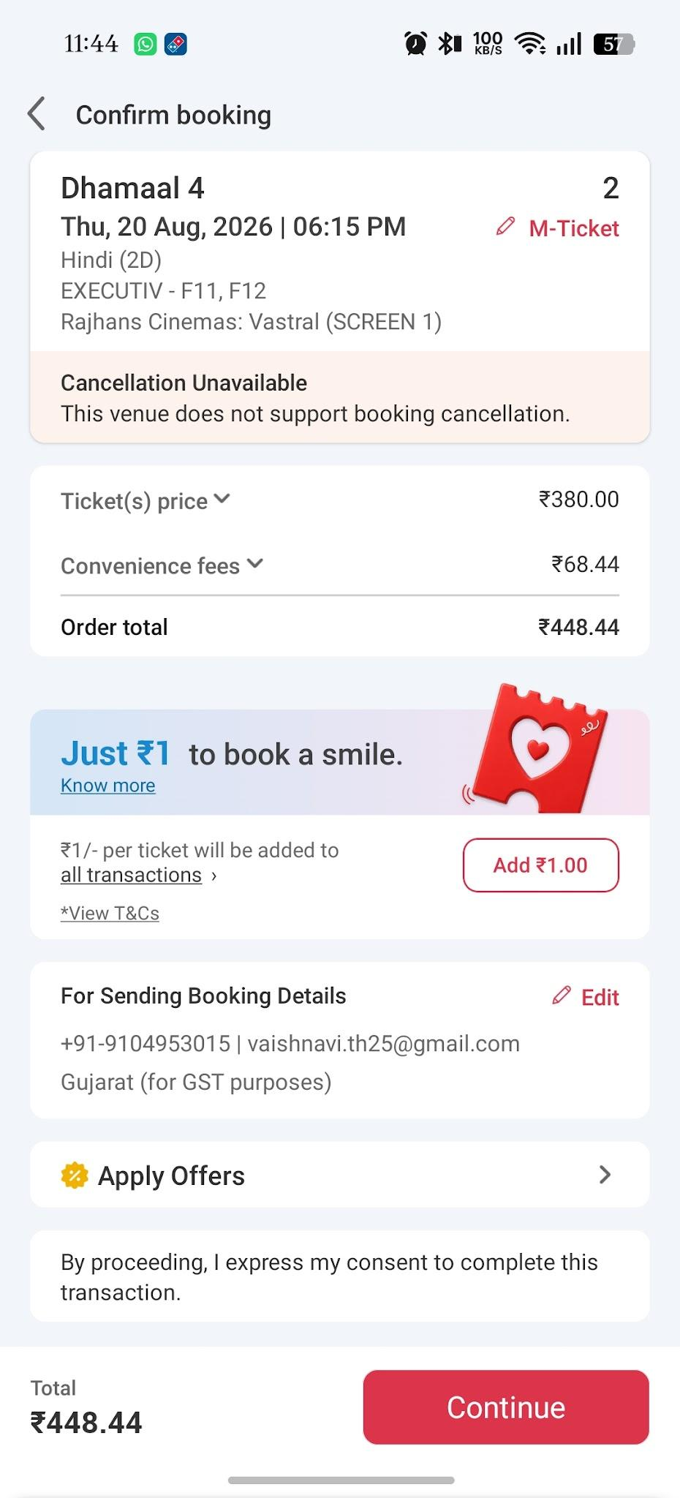
Scenario ID: BMS-011
Scenario: | Valid Offer/Coupon
Test Steps: | 1. Open offer/coupon section  2. Enter a valid applicable code  3. Apply
Test Input: | Valid applicable offer code
Expected Results: | Eligible discount should be applied and total amount recalculated.
Actual Results: | Applicable discount reflected in total.
Status: | Pass
Comments: | Offer calculation works as expected.
Screenshots:
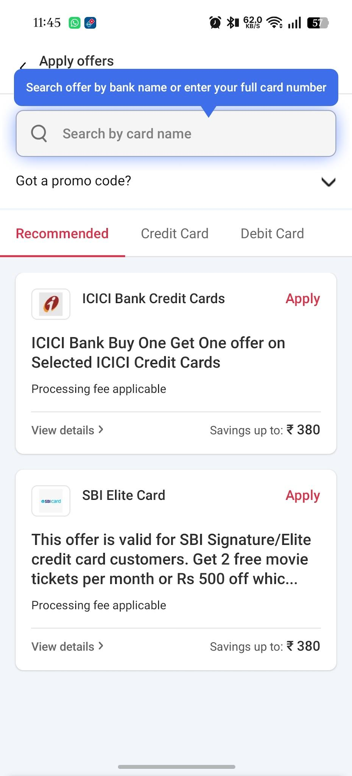

Scenario ID: BMS-012
Scenario: | Invalid Offer/Coupon
Test Steps: | 1. Open offer/coupon section  2. Enter invalid code  3. Apply
Test Input: | ICICI Bank credit card
Expected Results: | Validation/error message should appear and invalid discount should not be applied.
Actual Results: | Validation message appeared and discount was not applied.
Status: | Pass
Comments: | Invalid coupon handling is clear.

Scenario ID: BMS-013
Scenario: | Login During Booking
Test Steps: | 1. Start booking  2. Continue until login is required  3. Enter valid account details
Test Input: | Valid registered account
Expected Results: | User should be authenticated and returned to the booking flow.
Actual Results: | User authenticated and booking flow continued.
Status: | Pass
Comments: | Authentication flow works correctly.

Scenario ID: BMS-014
Scenario: | Payment with Valid Details
Test Steps: | 1. Complete booking details  2. Proceed to payment  3. Select supported payment method  4. Complete payment
Test Input: | Valid payment details
Expected Results: | Payment should complete successfully and booking confirmation should be generated.
Actual Results: | Payment completed and booking confirmation generated.
Status: | Pass
Comments: | Positive payment flow works.

Scenario ID: BMS-015
Scenario: | Payment Failure Handling
Test Steps: | 1. Proceed to payment  2. Use a payment attempt that fails/declines  3. Return to booking flow
Test Input: | Failed/declined transaction
Expected Results: | Failure message should be displayed and unsuccessful booking should not be confirmed.
Actual Results: | Failure message displayed and booking was not confirmed.
Status: | Pass
Comments: | Payment failure is handled.

Scenario ID: BMS-016
Scenario: | Booking Confirmation
Test Steps: | 1. Complete a successful booking  2. Open confirmation details
Test Input: | Successful booking
Expected Results: | Booking ID, movie, cinema, showtime and seat details should be displayed.
Actual Results: | Booking confirmation displayed with booking details.
Status: | Pass
Comments: | Confirmation details are available.

Scenario ID: BMS-017
Scenario: | Booking History
Test Steps: | 1. Sign in  2. Open account/profile  3. Open booking history
Test Input: | Registered user with booking
Expected Results: | Previous booking details should be displayed in booking history.
Actual Results: | Previous booking details displayed.
Status: | Pass
Comments: | Booking history works correctly.

Scenario ID: BMS-018
Scenario: | Responsive UI
Test Steps: | 1. Open BookMyShow on desktop  2. Resize browser window  3. Check navigation, movie cards and booking controls
Test Input: | Different desktop viewport widths
Expected Results: | UI should remain readable and usable without unintended overlap.
Actual Results: | UI remained readable and controls remained usable.
Status: | Pass
Comments: | Basic responsive UI check passed.

Scenario ID: BMS-019
Scenario: | Empty Search Validation
Test Steps: | 1. Open search  2. Leave search field blank  3. Submit/search
Test Input: | Blank search
Expected Results: | Application should not produce an invalid search result and should handle the empty input appropriately.
Actual Results: | Empty search handled without an invalid movie result.
Status: | Pass
Comments: | Negative search scenario handled.

Scenario ID: BMS-020
Scenario: | Back Navigation During Booking
Test Steps: | 1. Select movie/showtime  2. Open seat selection  3. Navigate back  4. Check application state
Test Input: | Back navigation
Expected Results: | Application should navigate back without crashing and maintain an understandable booking flow.
Actual Results: | Back navigation worked without application crash.
Status: | Pass
Comments: | Navigation flow is stable.

Summary of Test Results
Total Test Cases: | 20
Passed: | 20
Failed: | 0
Pass %: | 100.00%

Conclusion and Recommendations:
Pass Rate: 100.00% — The BookMyShow test scenarios documented in this report cover the primary movie discovery and ticket booking workflow. All recorded scenarios are marked Pass.
Recommendations: Continue testing with additional payment failure cases, session timeout cases, seat-lock/concurrency cases, accessibility checks, cross-browser checks, and mobile responsiveness before considering the complete workflow fully validated.
Bug Reports:
No failed test cases were recorded in the supplied BookMyShow test execution report; therefore, no specific bug report is included.

